**SRF PULLOUT REQUEST FORM**

**User’s Manual**

1. **Go to** [**http://10.27.1.170:9292/default.aspx**](http://10.27.1.170:9292/default.aspx) **and login your account.**

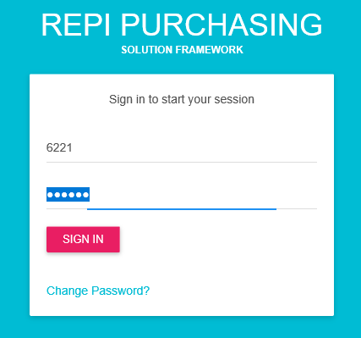

1. **Navigate SERVICE REPAIR to see all options assigned to your account.**

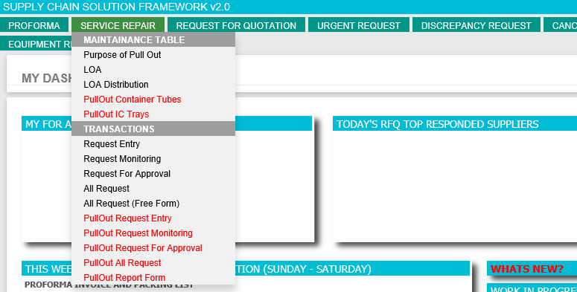

1. **If you want to create new request then go to SERVICE REPAIR > Transactions > PullOut Request Entry**

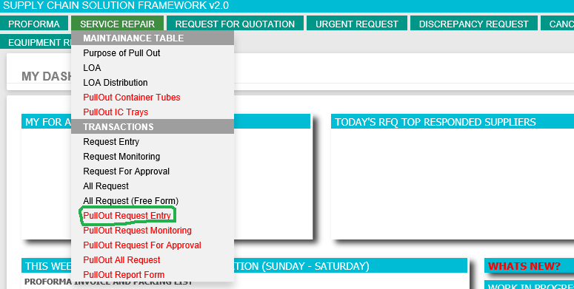

* **3.1 Enter all required field before clicking PREVIEW. If you missed to fill up required fields then the system will inform you. See example below;**

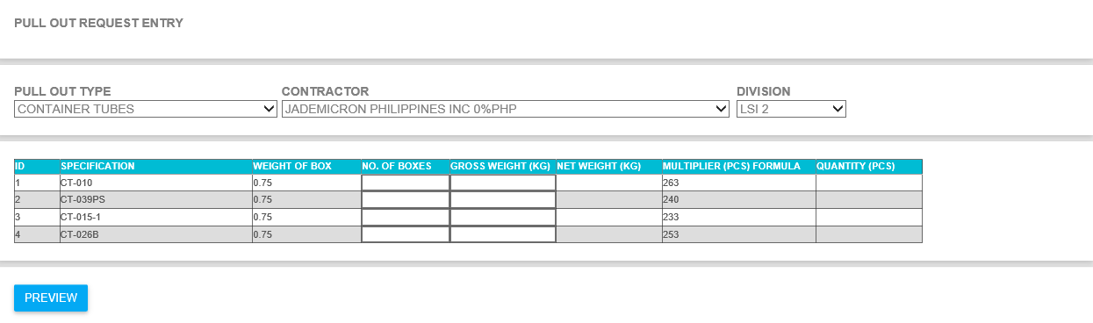

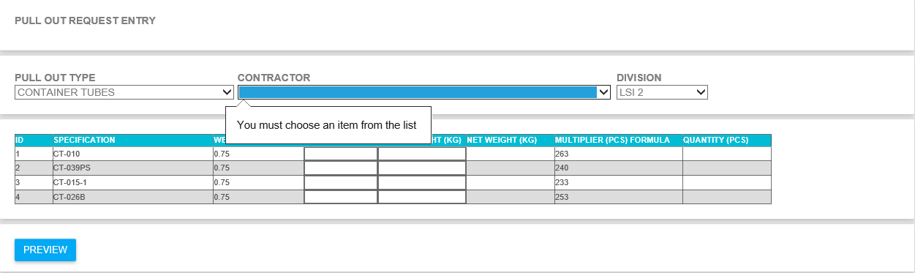

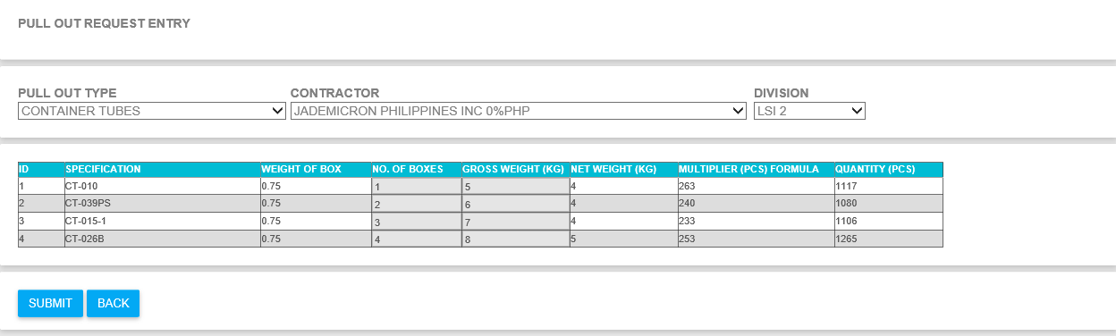

* **3.2 Enter your number of boxes and gross weight then click PREVIEW. If you are good or satisfied with the generated result after click preview button the click SUBMIT to proceed with your request. If you noticed that your item or specification is not in the list, please inform buyer to update accordingly.**
* **3.3 You will be redirected to success page if there is no error after clicking SUBMIT Button**

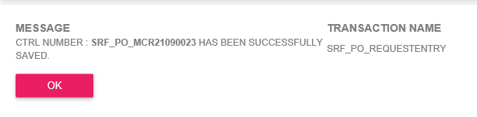

1. **If you want to check or monitor your request the go to SERVICE REPAIR > Transactions > PullOut Request Monitoring**

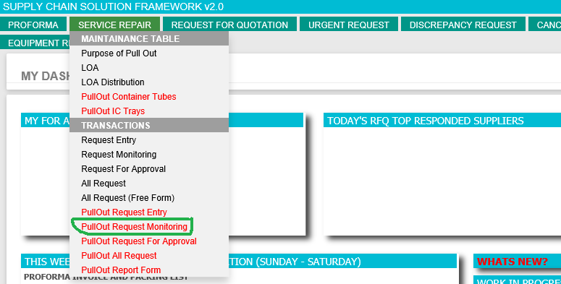

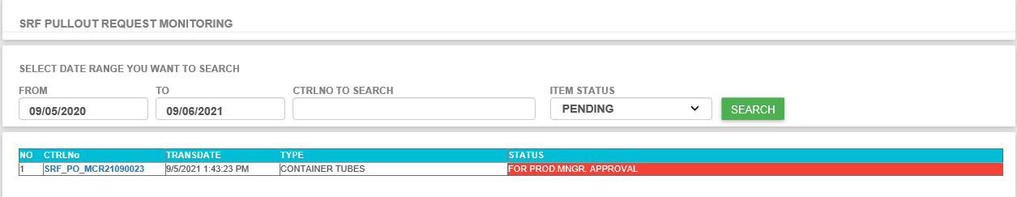

* **4.1 Click CTRL No Number if you want to see the request details.**

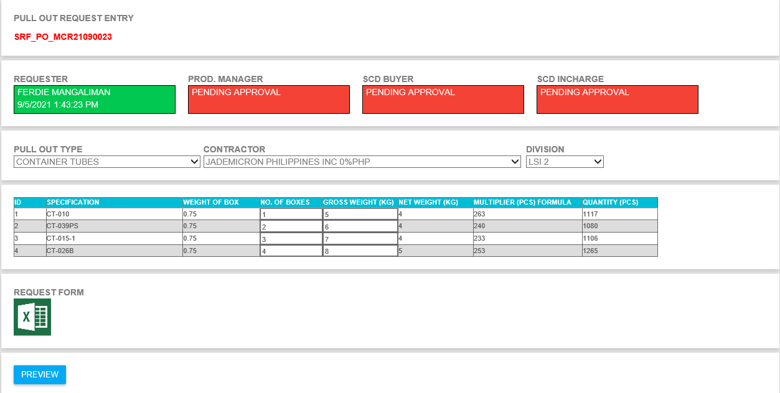

* **4.2 If you missed something on your request then you have chance to update it before your production manager approve the request.**
* **4.3 To download the Request Form, just click the REQUEST FORM Excel Icon.**

1. **If you want see all request the go to SERVICE REPAIR > Transactions > PullOut All Request. This page is almost the same with the RFQ All Request Form for your reference.**

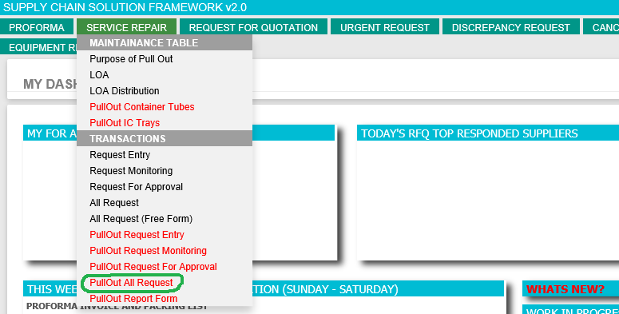

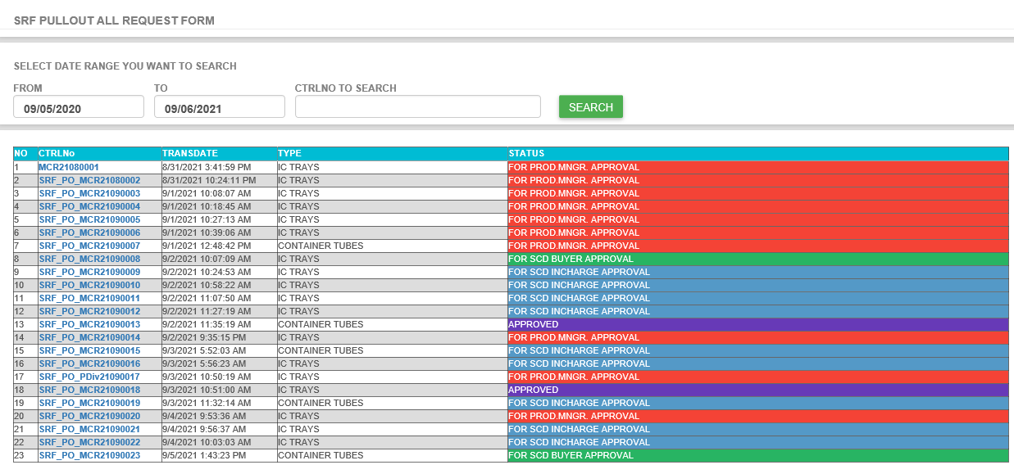

1. **If you want to approved request then go to SERVICE REPAIR > Transactions > PullOut Request For Approval**

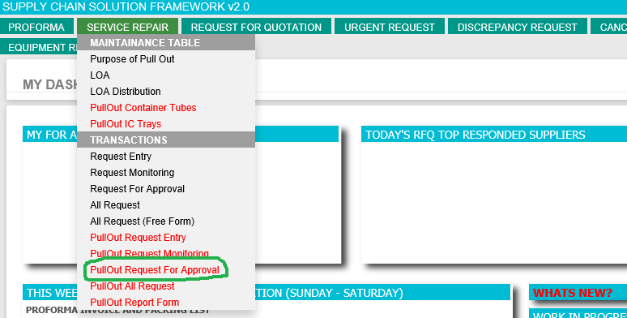

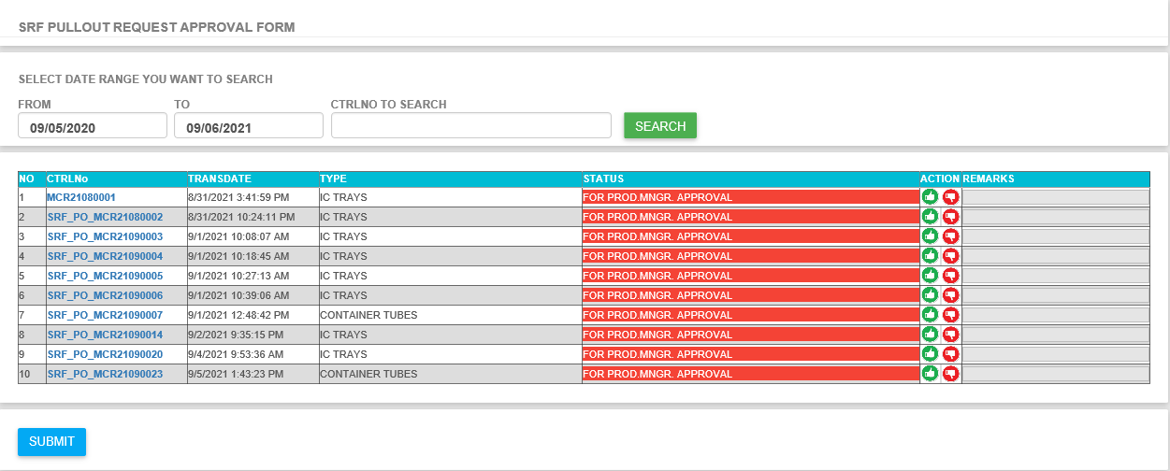

* **6.1 Click CTRLNo if you want to see the request details**
* **6.2 If request is good and ready for approval then click the green thumbs up button in ACTION column then click SUBMIT.**
* **6.3 If no error then you will be redirected to successful page.**

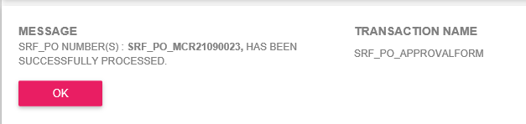

* **6.4 If you want to reject or disapproved request then click the red thumbs down button, add your disapproval remarks then click submit.**

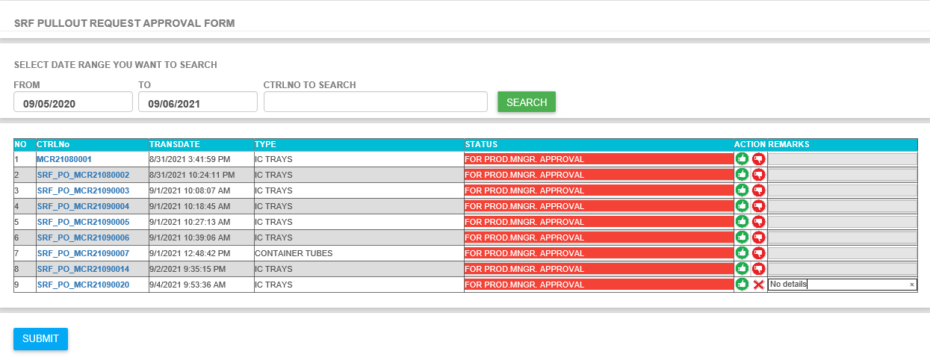

1. **If you want to see all request then go to SERVICE REPAIR > Transaction > PullOut All Request**

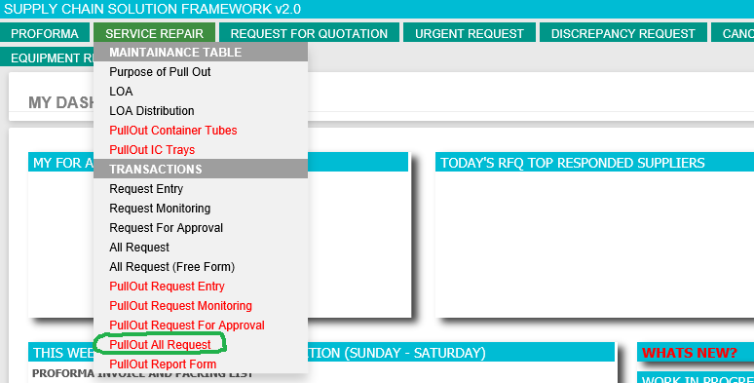

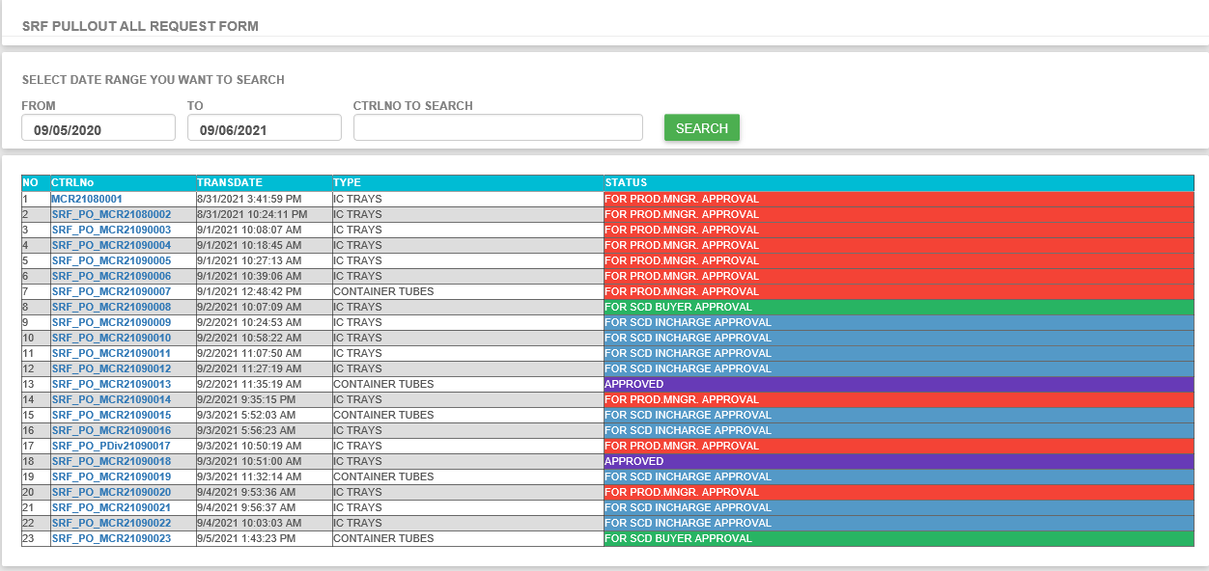

* **7. 1 Click CTRLNo if you want to see the request details**

1. **If you want to see PULL OUT Report Form then go to SERVICE REPAIR > Transactions > PullOut Report Form (STRICTLY FOR *SCD Staff* Only)**

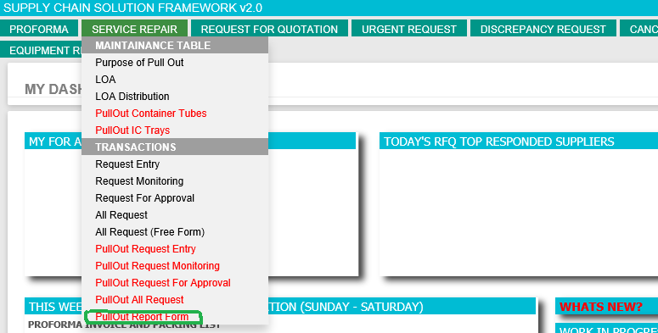

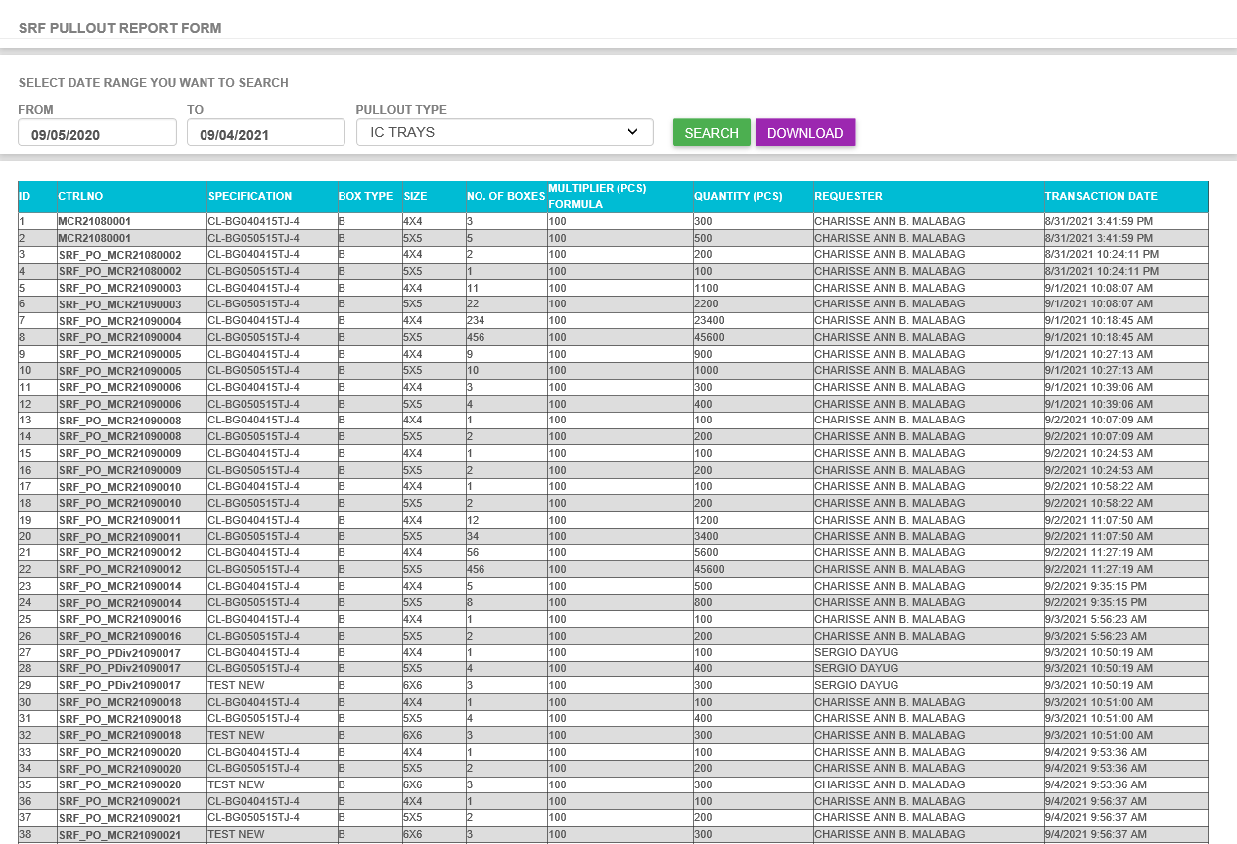

* **8.1 Before clicking the DOWNLOAD button make sure that you populate the table first. Select the desired date range the click SEARCH Button. If records are not empty then you will be able to DOWNLOAD it to Excel File by Clicking the DOWNLOAD Button.**

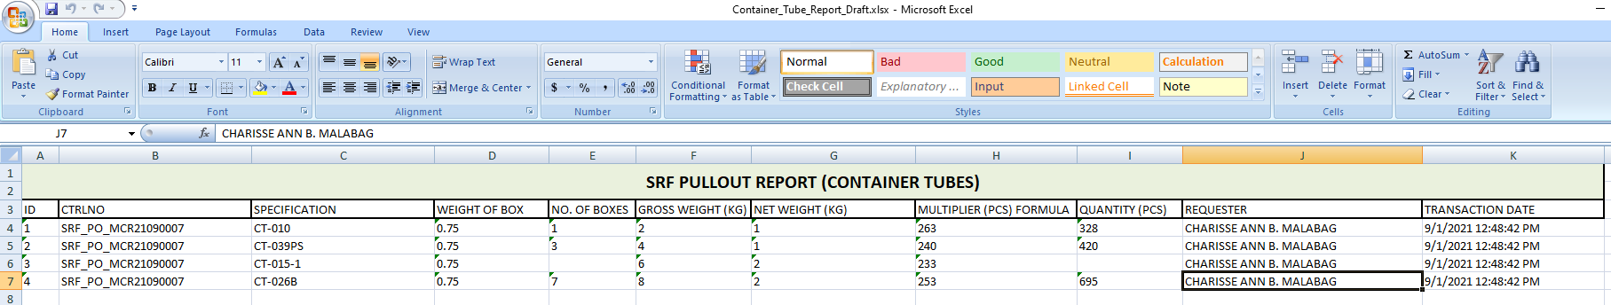

1. **If you want to update the PULLOUT Container Tube Maintenance Table then go to SERVICE REPAIR > Maintenance Table > PullOut Container Tubes (STRICTLY FOR *SCD Staff* Only)**

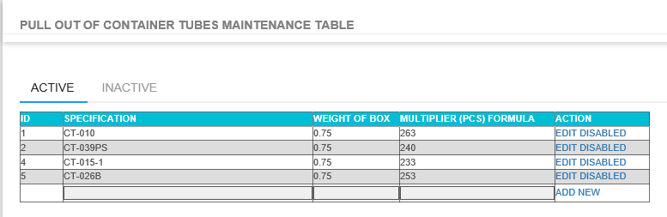

1. **If you want to update the PULLOUT IC Trays Maintenance Table then go to SERVICE REPAIR > Maintenance Table > PullOut IC Trays (STRICTLY FOR *SCD Staff* Only)**

